Project Design Phase
Solution Architecture

Date | 15 February 2025
Team ID | LTVIP2025TMID36086
Project Name | Enchanted Wings: Marvels of Butterfly Species
Maximum Marks | 4 Marks

Solution Architecture:
Solution architecture is a complex process – with many sub-processes – that bridges the gap between business problems and technology solutions. Its goals are to:
- Find the best tech solution to solve existing business problems.
- Describe the structure, characteristics, behavior, and other aspects of the software to project stakeholders.
- Define features, development phases, and solution requirements.
- Provide specifications according to which the solution is defined, managed, and delivered.

Example - Solution Architecture Diagram:

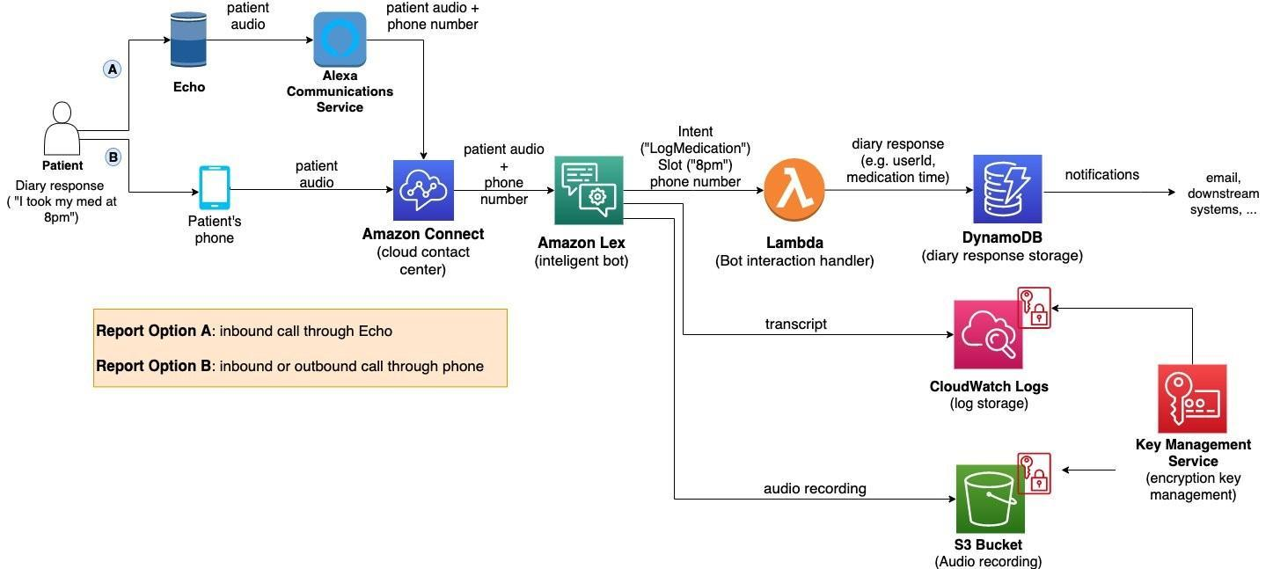
Figure 1: Architecture and data flow of the voice patient diary sample application
Reference: https://aws.amazon.com/blogs/industries/voice-applications-in-clinical-research-powered-by-ai-on-aws-part-1-architecture-and-design-considerations/

🔍 Solution Architecture Overview
Solution Architecture bridges the gap between biodiversity-related challenges and cutting-edge deep learning solutions. It defines the overall structure and flow of how data, models, and users interact with the application.
The architecture ensures real-time butterfly classification using pre-trained CNN models, while also considering scalability, modularity, and end-user usability.

🎯 Objectives of the Architecture
- Identify butterfly species using image input from end users.
- Use transfer learning (VGG16) for efficient, high-accuracy prediction.
- Enable interactive and educational web-based classification interface.
- Ensure modular design for retraining, scaling to new species, or platform deployment.

🧱 Solution Components
- Data Pipeline
  - Input: 6499 labeled images (75 butterfly species)
  - Image augmentation and preprocessing using Keras ImageDataGenerator
- Model Architecture
  - Base Model: Pre-trained VGG16 (ImageNet weights)
  - Custom Layers: Flatten → Dense(256) → Dropout → Dense(75 softmax)
- Training Environment
  - TensorFlow/Keras in Jupyter Notebook/Google Colab
  - GPU acceleration for training and fine-tuning
- Model Evaluation
  - Accuracy and loss plots, confusion matrix
  - Final model exported (.h5 format)
- Deployment Layer
  - Web interface using Streamlit
  - User uploads butterfly image → Receives predicted species with confidence score
- User Feedback Loop (optional future phase)
  - Feedback collection for wrong predictions
  - Option to submit images to improve model accuracy over time
📊 Architecture Diagram
